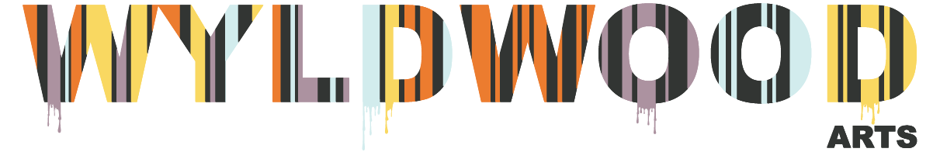
Access Page – Easy Read Guides
Keyboard Browsing tips

Summary:
This guide has been created to help you with keyboard browsing as a way to view our website.

Making text bigger or smaller
On a computer that has Windows, Linux or Chrome OS, press Ctrl and + on your keyboard to make the text bigger. To make the text smaller, press Ctrl and -

Using your keyboard to move around a website
Press the Tab key on your keyboard and this will allow you to move forward through a website. To move backwards, press the Shift and Tab key at the same time.
You can move forwards and backwards on a website using your keyboard to access:

- Links
- Text fields on forms
- Maps
- The web address bar
- The tabs bar
- HMTL frames (Framesets)

Caret Browsing
Pressing the F7 key on your keyboard allows you to use Caret Browsing. This means you can use the standard navigation keys to:

- Select text
- Move around a website
The standard navigation keys (meaning, those that have a direction) are:

- Home
- End
- Page Up
- Page Down
- Arrow keys

About Wyldwood Arts
Wyldwood Arts is an arts charity based in the Forest of Dean.
You can find out more about us:
By visiting our website at wyldwoodarts.co.uk
By visiting our social media accounts:

On Facebook, Instagram and Twitter we are @wyldwoodarts

